A000-US-MN-Pipe-Rattlesnake-MN Pipestone Quarry-Catlinite-W Dakota-Yankton-18th c

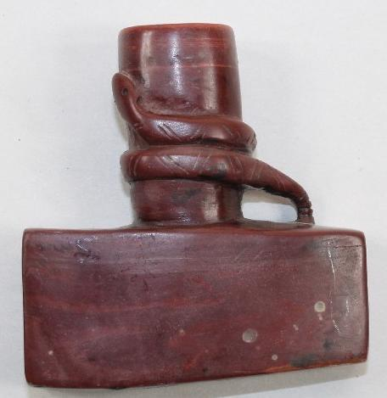

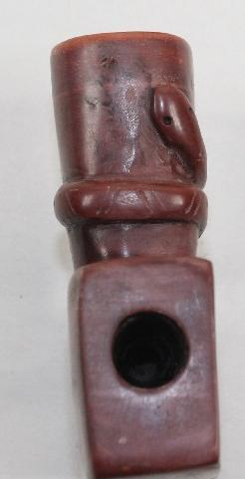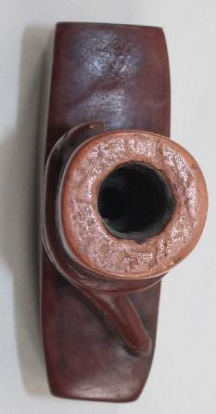

Figs 1-3, side, end, top. US-MN-Pipe-Rattlesnake-MN Pipestone Quarry-Catlinite-W Dakota-Yankton-18th c

Case no.: 11

Accession Number:

Formal Label: US-MN-Pipe-Rattlesnake-Minnesota Pipestone-Catlinite-W Dakota-Yankton-18th c

**Display Description:**

This catlinite Rattlesnake Effigy Pipe incorporates two elements into its structure. The first element is a now lost pipe stem mouthpiece, which having been made of wood or reed disintegrated in its burial soil. This mouthpiece is termed a “calumet,” which is derived from the Norman word “chalumeau,” meaning “reed”, which was coined by the first French missionaries of the latter 17h c. Pipe stems are considered more spiritually powerful than stone or ceramic pipe bowls. A “calumet” represents the energetic male principle.

The second element is the carved Rattlesnake Effigy Pipestone bowl that metaphorically represents powers associated with the female principle of socially and sexually conjoining. The snake conjoins in its grasp the smoker. However, the rattlesnake effigy is meant not to refer to this particular fauna but to its Hopewellian metaphor. Hence, the metaphor is to join fast to the groups smoking the tobacco. Together, the stem and the bowl represent the principle of harmony, and they are to be joined only during a ritual smoking of tobacco when concluding a ritual association among participants.

**LC Classification:**

Date or Time Horizon: 18th c

Geographical Area: Pipestone, Minnesota

**Map:**

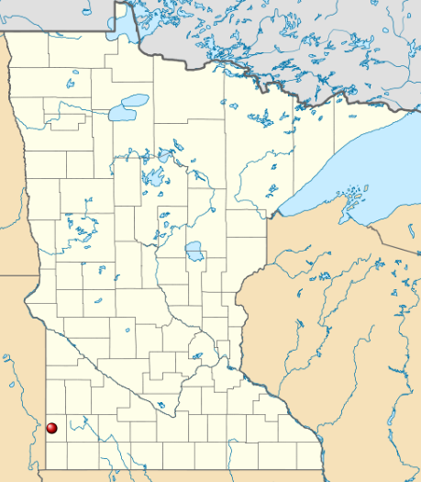

Pipestone Quarry location in MN. After https://en.wikipedia.org/wiki/File:USA_Minnesota_location_map.svg

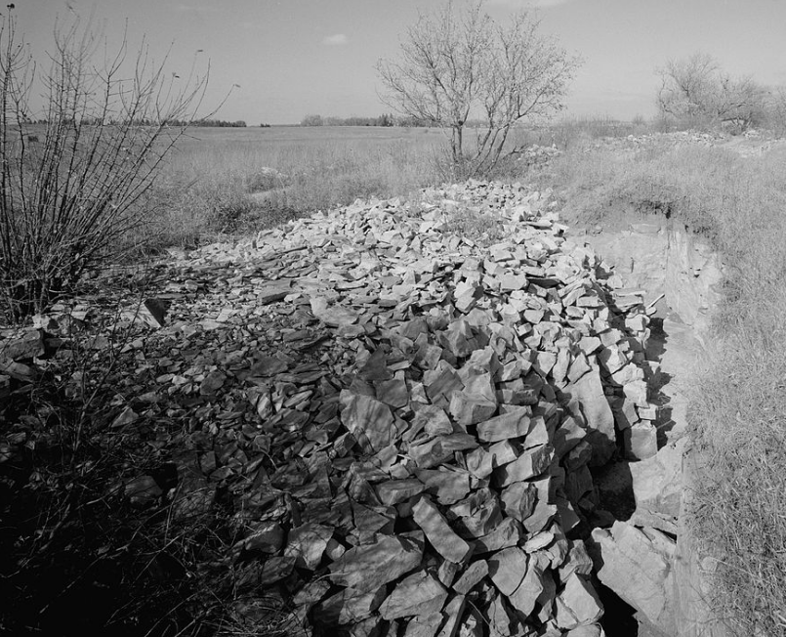

[Pipestone National Monument](https://en.wikipedia.org/wiki/Pipestone_National_Monument) ([44°0′48″N 96°19′31″W](https://tools.wmflabs.org/geohack/geohack.php?pagename=File:Pipestone-NM.jpg&params=44_0_48_N_96_19_31_W_)), Rock Quarry, Park Entrance Road, Township 106N, Range 46W, Pipestone vicinity, Pipestone County, MN. Historic Quarry, looking north. Image has been cropped to remove the photographer's shadow. C 1920, photo by unidentified Park Employee. United States [Library of Congress](https://commons.wikimedia.org/wiki/Library_of_Congress)'s [Prints and Photographs division](https://www.loc.gov/rr/print/) under the digital ID [hhh.mn0130](http://hdl.loc.gov/loc.pnp/hhh.mn0130).

**GPS coordinates:** [44°0′48″N96°19′30″W](https://tools.wmflabs.org/geohack/geohack.php?pagename=Pipestone_National_Monument&params=44_0_48_N_96_19_30_W_type:landmark_region:US-MN)

Cultural Affiliation: The Očhéthi Šakówiŋ people (pronounced [oˈtʃʰetʰi ʃaˈkowĩ]) or **Seven Council Fires** of the Great Siouan Nation are grouped into three regional/dialect groups (Lakota, Western Dakota, and Eastern Dakota), of which this pipe is affiliated with the second, known as Yankton (Iháŋktȟuŋwaŋ) -Yanktonai (Iháŋktȟuŋwaŋna) or Dakȟóta. Thy had been erroneously classified as "Nakota” (Buechel and Manhart 2002 [1972]).

Medium:

Minnesotapipestone which is solely termed “catlinite” after the artist George Catlin (1796 –1872) who itinerated and painted in the area, is a type of argillite (metamorphosed mudstone) brownish-red in color, which occurs in a matrix of Sioux Quartzite. Catlinite is fine-grained and only easily worked if it is recently quarried, because oxidation progressively hardens the stone. Catlinite, because it is found in large, thick strata, is ideal for making pipes, especially disk pipes. The second reason for the almost exclusive use of catlinite for red pipes and tablets may relate to the spiritual power of red (blood color) and the ancient qualities of the catlinite quarries. Lewis and Clark (Thwaites 1904:115, 1905:44– 45) and Catlin (1973 [1844]:167–169) reported that the Sioux considered the area around the Minnesota catlinite quarries to be sacred and the red stone powerful.

Dimensions: almost 3" long T-Bowl Pipe that is 3" tall by 1" wide; The bowl is 1/2" by 1-1/2" deep. The stem hole is 7/16" in diameter.

Weight:

Condition: The rim of the bowl indicates considerable evidence that it has been knocked to get out used tobacco.

Provenance:

**Discussion:**

**References:**

Buechel, Eugene, S.J. (Editor), Paul Manhart, S.J. (Editor) 2002 [1972]. *Lakota Dictionary: Lakota-English / English-Lakota*, New Comprehensive Edition. Omaha, NE: University of Nebraska Press.